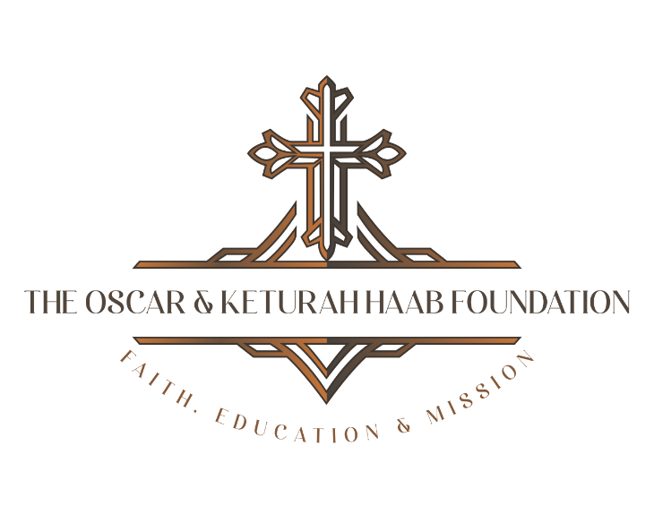

Hear More About Oscar & Kay
…and how they changed the world.

Request a speaker:

Conference

Webinar

Bible Study

Retreat

(In person or via digital presentation)

Email for a list of presentations available.

grants@thehaabfoundation.com

3588 Plymouth Road, #322 Ann Arbor Michigan 48105

Psalm 46 God is our refuge and strength, a very present help in trouble.

