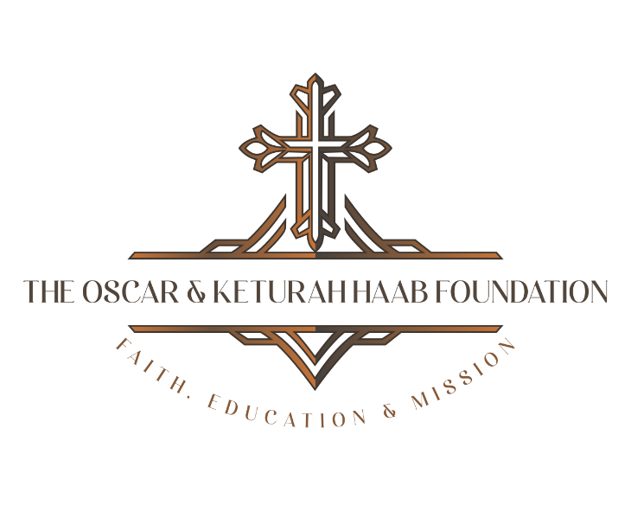

Current Board Members
The Oscar & Keturah Haab Foundation

Dr. Ronald M. Allen, Vice President

Mrs. Janet Allen

Mr. Kenneth Bachman

Mrs. Elaine Bachman, Secretary

Ms. Ilona Heckert

Ms. Mary Kay Salminen, President

Dr. Charles Schmude

Ms. Ruth Schmude

Larry & Sandy Seltz

3588 Plymouth Road, #322 Ann Arbor Michigan 48105

grants@thehaabfoundation.com

Psalm 46 God is our refuge and strength, a very present help in trouble.

