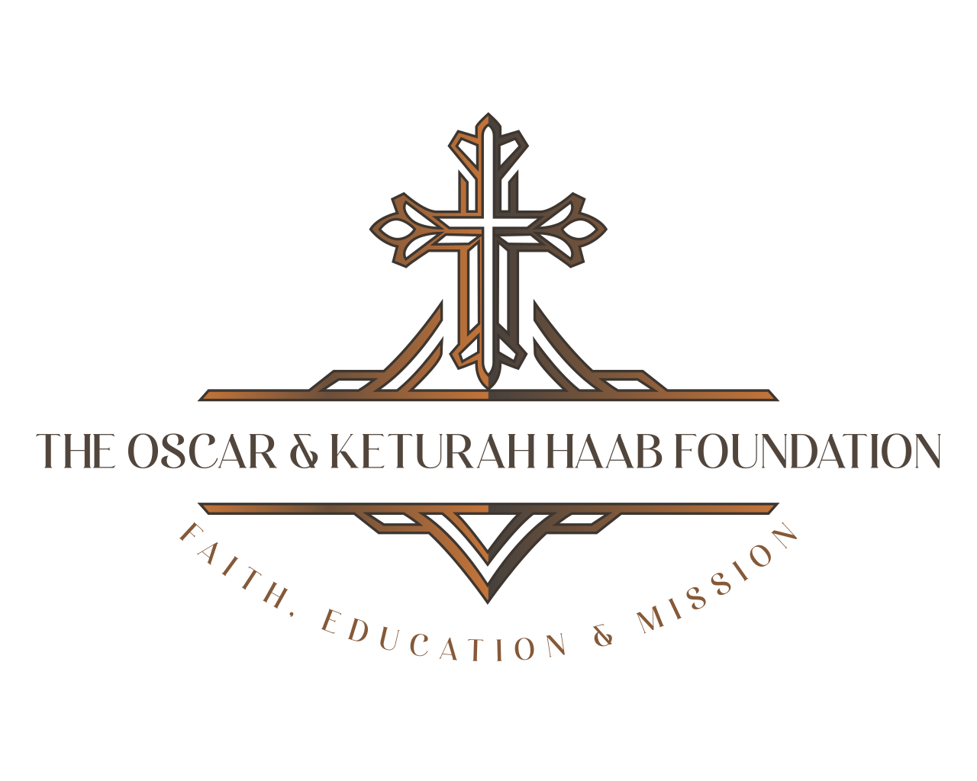
2026-2027 Foundation Guidelines

Grants range from $1000 to $15,000, with the majority of grants between the $ 5,000 and $10,000 range. New grantees begin at the $1,000 level.

The Foundation accepts grants with the enclosed Charity Information Form completed. Grantees are encouraged to contact the Foundation prior to their grant submission. Please include:
- A brief description of the history, purpose, and activities of your organization.
- A statement of need for support with expected outcomes and measures.
- A copy of the current program/operating budget.
- A breakdown of funding resources.

New Charities:
- Certificate of tax exemption
- Board of Directors List
- Copy of Annual Report, newsletter or publicity materials.

Eligibility (One or more of these emphasis areas):
- Christ-Centered
- Education/Learning Focused
- Mission & Outreach

Deadline: Please provide a 3-5-page proposal submitted in a digital format by October 15th. The grants will be voted on during the December meeting and awarded before year-end.

Lastly, when you send in your grant, you agree to the terms of the grant as stated. Life happens, we understand that. If you or your organization are unable to meet the terms of the grant, please contact us immediately. You will then have 90 days to either send us a proposal to repurpose the funds or refund the money. We will then vote on the repurposed agreement. If the board chooses not to fund the repurposed proposal, then your charity must return the grant money to The Oscar & Keturah Haab Foundation.

Kindest Regards,
Mary Kay Salminen
President
The Oscar & Keturah Haab Foundation

3588 Plymouth Road, #322 Ann Arbor Michigan 48105
grants@thehaabfoundation.com
Directors: Ronald Allen, Janet Allen, Kenneth Bachman, Elaine Bachman, Ilona Heckert, Mary Kay Salminen, Charles Schmude, Ruth Schmude, Larry Seltz, Sandra Seltz

Psalm 46 God is our refuge and strength, a very present help in trouble.

